John Michael Go
Career Entry Level Java Programming
Date: Jan. 22, 2013

DAY 8

Program Name: ArraysOddEven

Objective: This is a program that sorts even an odd numbers between 1 to 10.

Algorithm:

1. Program outputs even an odd numbers between 1 to 10.

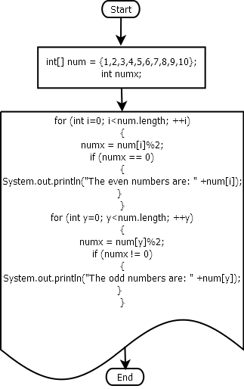
Flowchart:

Pseudocode:

public class ArraysOddEven {

public static void main(String[] args) {

int[] num = {1,2,3,4,5,6,7,8,9,10};
int numx;

for (int i=0; i<num.length; ++i)
{
numx = num[i]%2;

if (numx == 0)
{
System.out.println("The even numbers are: " +num[i]);
}

}

for (int y=0; y<num.length; ++y)
{
numx = num[y]%2;

if (numx != 0)
{
System.out.println("The odd numbers are: " +num[y]);
}

}

}

}

Screenshots:

